Case 4-A93**-A94-A95-A96-A97**-Eur-Roman-Lamp-Clay

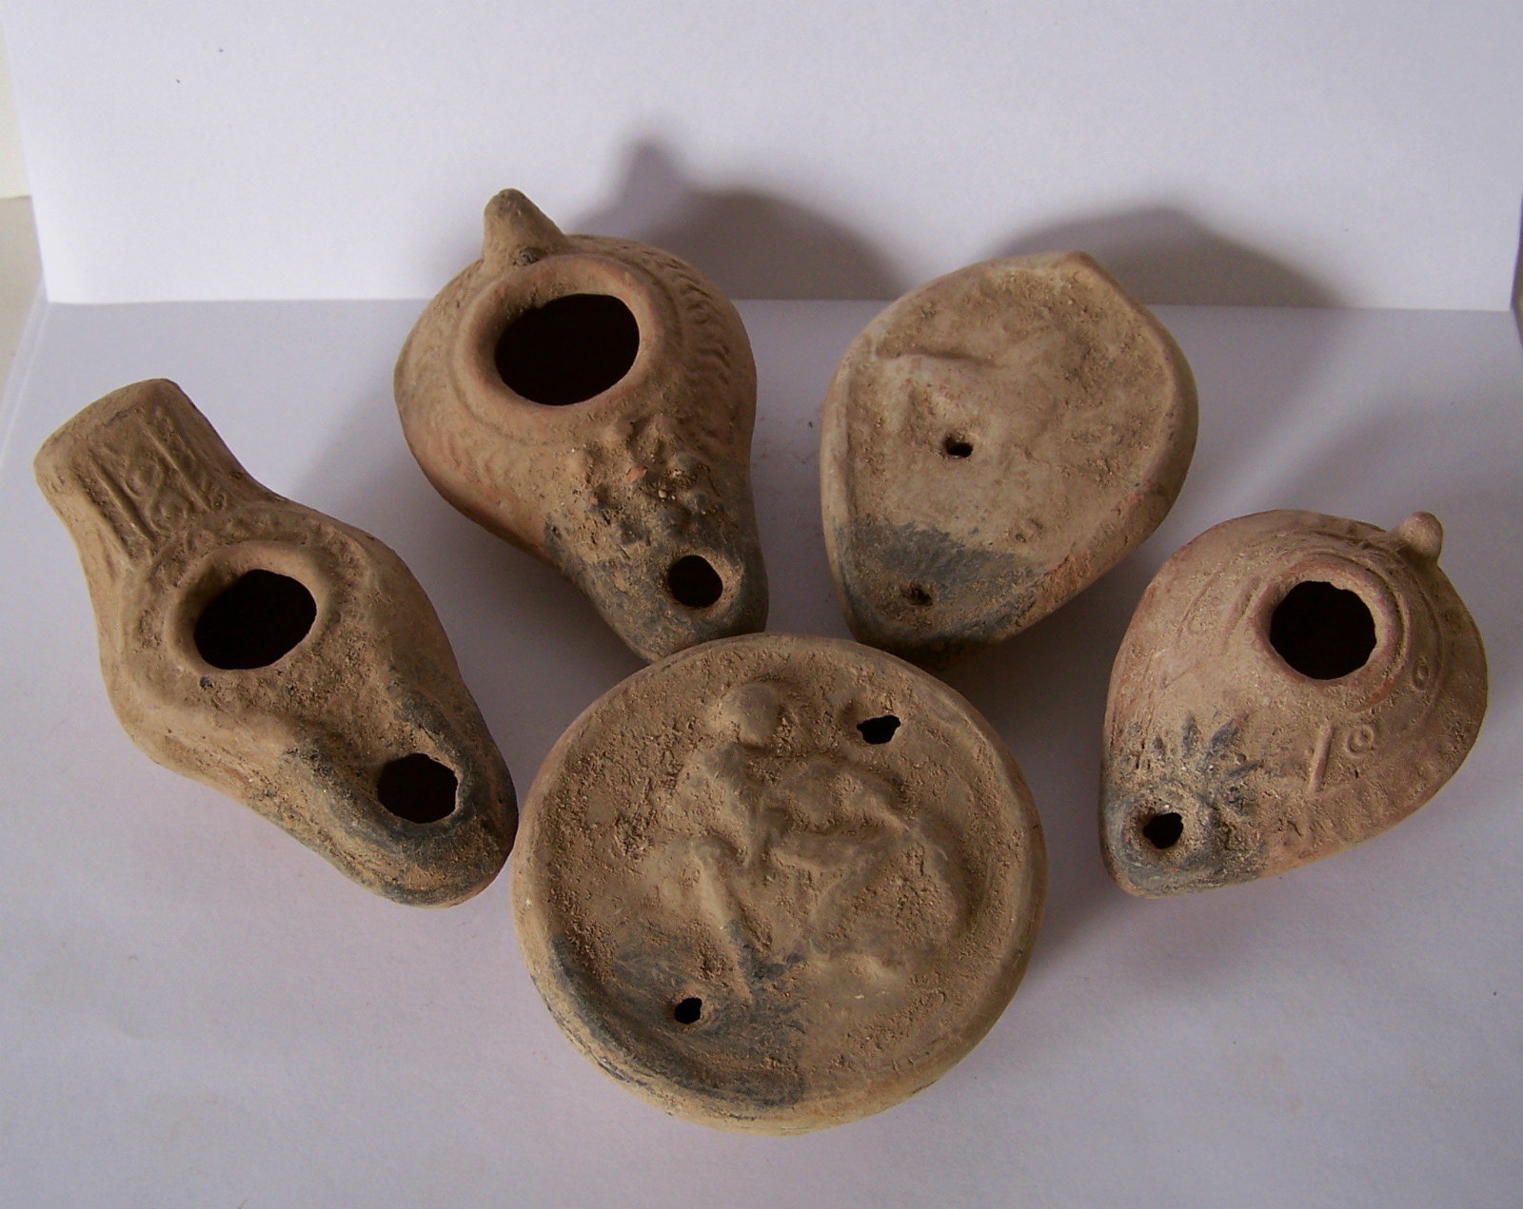

**Case No.: 4**

**Accession Number: A93-A94-A95-A96-A97**

**Formal Label: Roman-Lamp-Clay**

**Display Description:**

For the ancient Romans, lamps were more than just a way to be able to see in the dark—they were mythical muses, witnesses to secrets, and instruments of the supernatural. Far more familiar to the average Roman than the high art of mosaics, statues, or frescos, lamps created the atmosphere of day-to-day life in the homes, workshops, and public houses of Roman provincial towns.

**LC Classification:** NB.150.R57

**Date or Time Horizon:**

**Geographical Area:**

**Map:**

**GPS Coordinates:**

**Cultural Affiliation:**

**Geographical Area:**

**Medium:**

**Dimensions**:   
**Weight:**

**Provenance:**

**Condition:**

**Discussion:**

**References:**